

***JOIN US FOR OUR***

***ANNUAL***

***LENTEN RETREAT***

***In April***



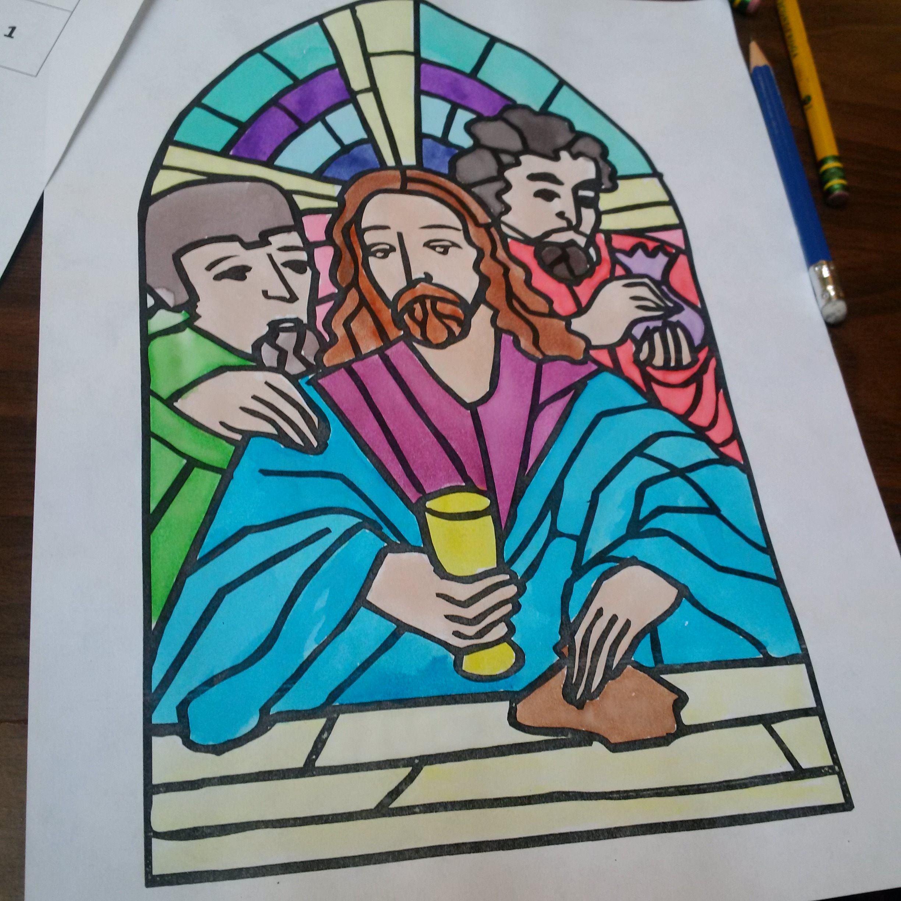

MARCH, 2017

|  |  |
| --- | --- |
| **March 5th**  **\*\*bring your special icons from home** | **Sunday of Orthodoxy**  **John 1:43-51**  **http://onlinechapel.goarch.org/images/GreatLent/01_firstlent1cp.jpg** |
| March 19th  **Special lesson on The Annunciation of the Virgin Mary | **Veneration of the Cross** |
| March 26th  [https://encrypted-tbn1.gstatic.com/images?q=tbn:ANd9GcRKo0TTDgglwfk-Qs7l98R_JhOLTLJv13bbnDN-FdYHgtdfysGNXdAXyGIz](https://www.google.ca/url?sa=i&rct=j&q=&esrc=s&source=images&cd=&cad=rja&uact=8&ved=0ahUKEwilz9y63_nRAhWExYMKHVQtBvgQjRwIBQ&url=https://commons.wikimedia.org/wiki/File:Flag_of_Greece.svg&psig=AFQjCNH-qjfrCKS17HVBaMLa4OyuIPwFMA&ust=1486411227272020) | **Annunciation of the Virgin Mary**  **March 25th Celebration**  **Greek Independence Day ceremony at City Hall, proclamation by Mayor Bryan Paterson**  **AND the raising of our**  **GREEK FLAG** |